VSITAS PARCIAL PROGRAMACION MOVIL

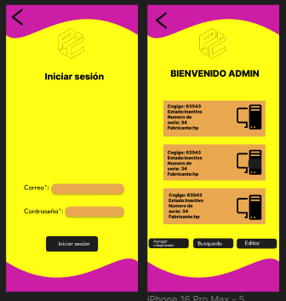
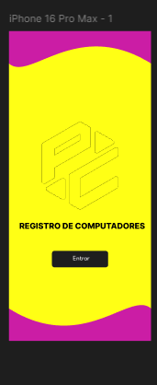

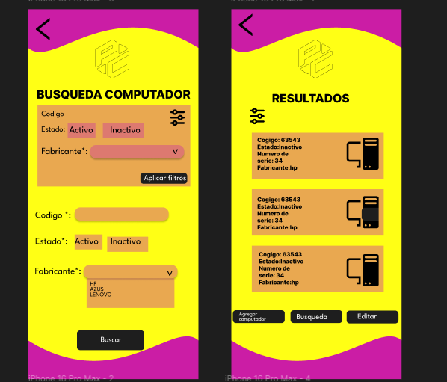

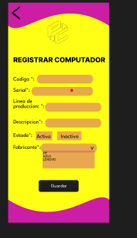

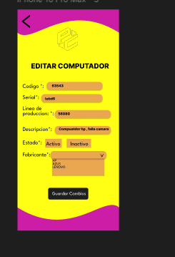

Link github : https://github.com/bsbedoya/programacion-movil-2025-a-g2
Link figma: https://www.figma.com/design/4FGCxYIF5wa93z8zLa3PIC/Parcial-programacion-movil?node-id=0-1&t=Quc9aEbM4gndqKLT-1

